**Lesson Topic: Sexually Transmitted Diseases and HIV**

Objectives:

* State that abstinence from sexual activity and needle sharing are the only ways that are 100% effective at avoiding STI and HIV Transmission
* Understand communication is an fundamental part of sexual health
* Describe the signs, symptoms and treatments of most common STIs
* Describe the nature of HIV and how it is transmitted, prevented and treated

Activities:

Video:

What Are STDs? #FACTCHECK: <https://youtu.be/7Sbgg8icODY>

Let’s Talk about Sexual Health (seeing a medical provider): <https://vimeo.com/43631114>

Get Tested (HIV,STD, and hepatitis testing): <https://gettested.cdc.gov/>

STD/HIV Jeopardy game

PowerPoint slides 2-4

**Abstinence**

WCSD Definition

* + **Sexual Abstinence is defined as refraining from all forms of sexual activity and genital contact such as vaginal, oral and anal sex.**
  + **An abstinent person is someone who has either never had sex or someone who’s had sex but who has decided not to continue having sex for a period of time.**
  + **Abstinence is the only 100% effective way to prevent HIV, other sexually transmitted diseases or infections and pregnancy.** 
    - SEX-when a person’s genitals touch another person’s genitals, mouth or anus.

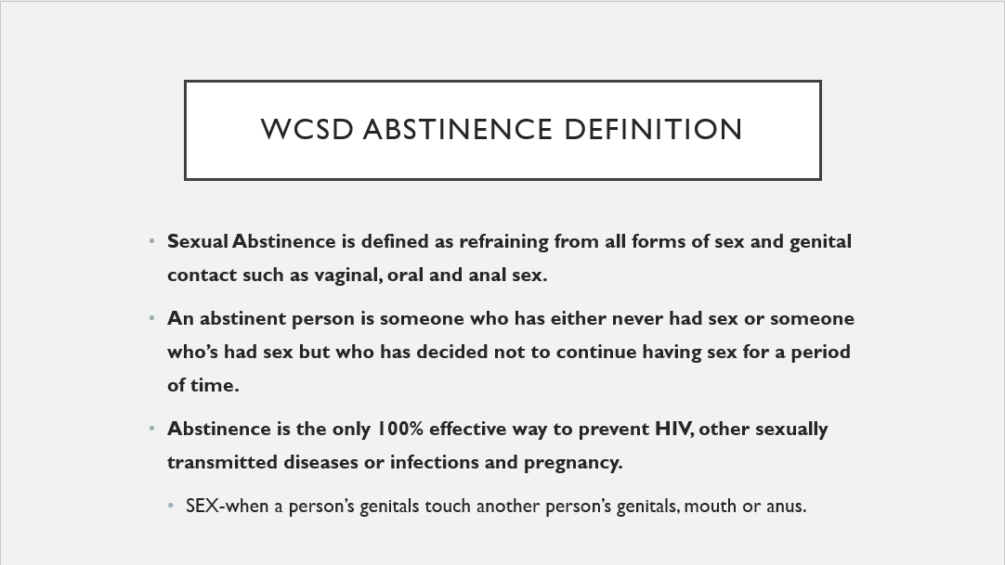

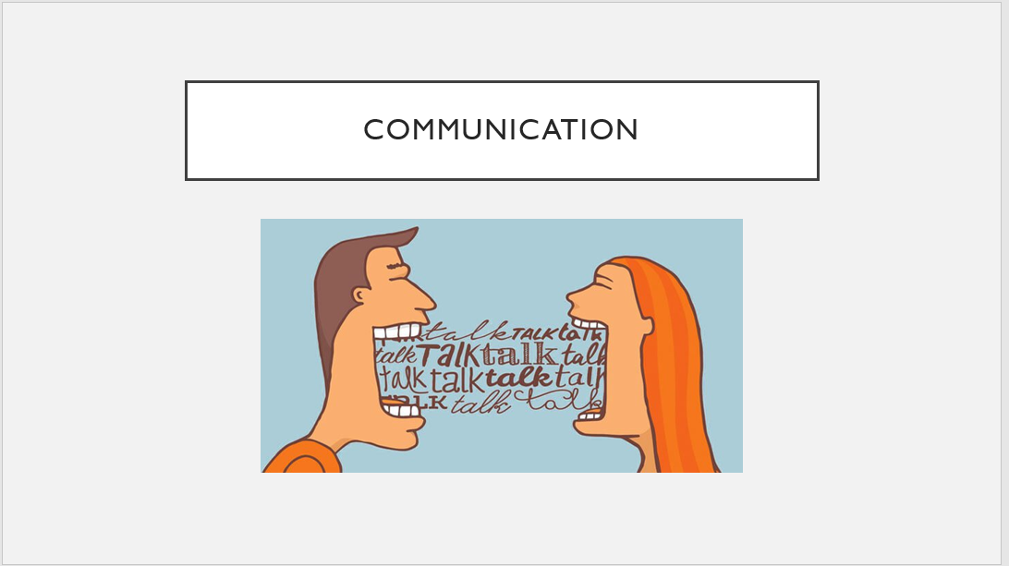

Slide 4:

Communication- partners must communicate about their individual definitions/thoughts on abstinence.

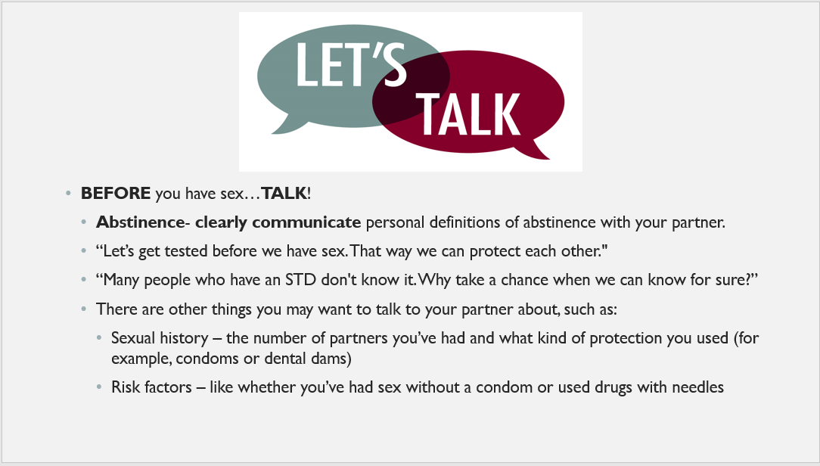

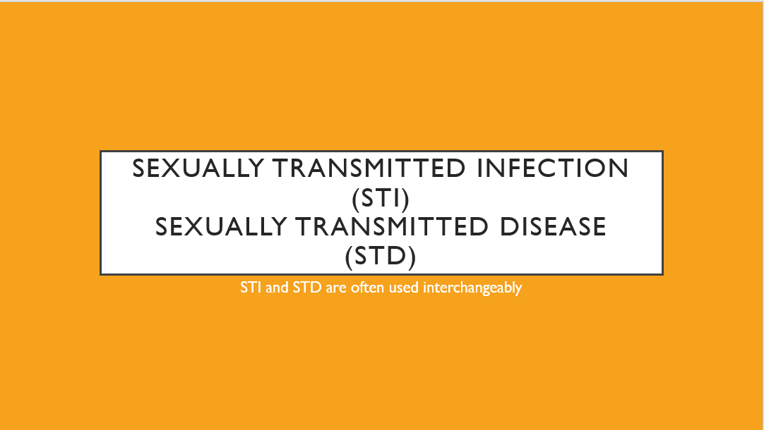

Slide 6- What Are STDs#Factcheck video

* What do you recall about STDs/STIs from your previous years of SHARE?

Play video clip embedded in slide

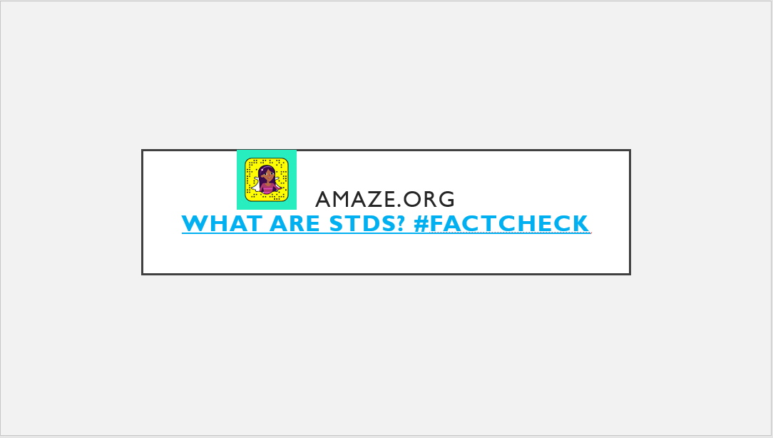

STDs/HIV

Go over slides 7-38

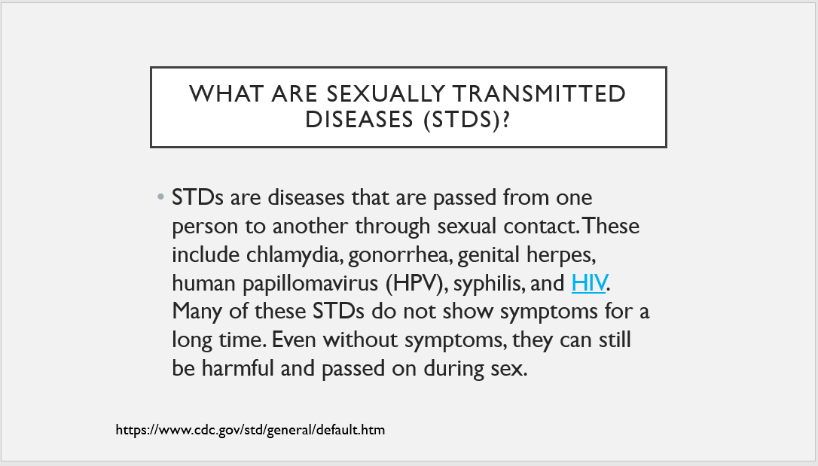

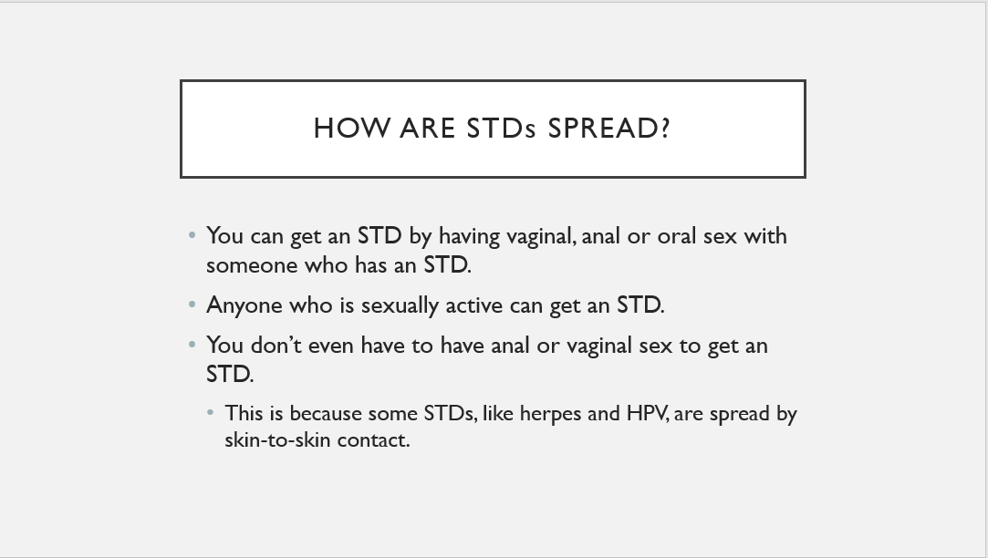

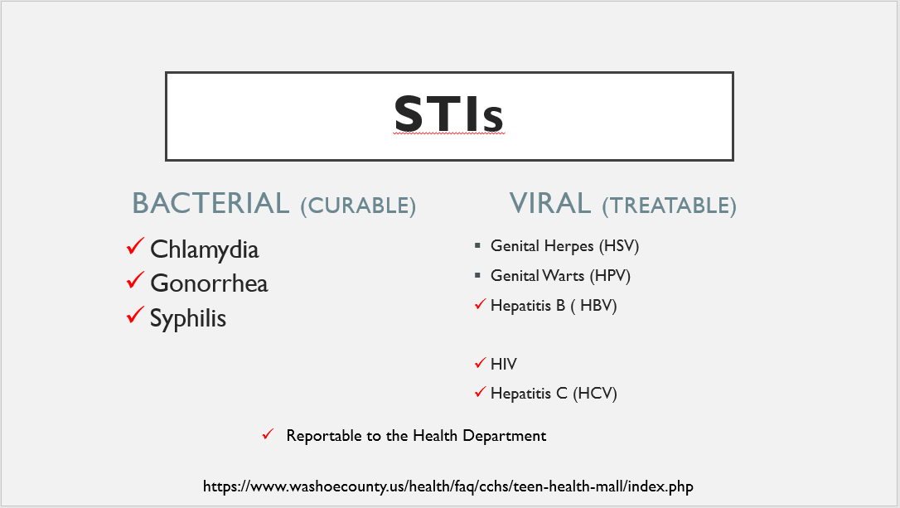

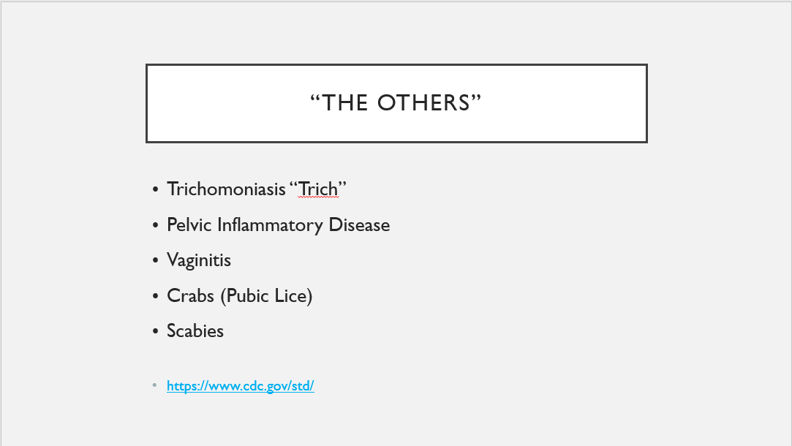

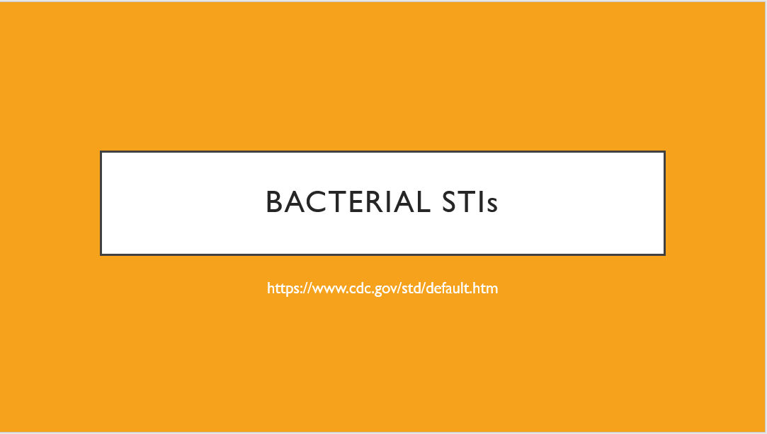

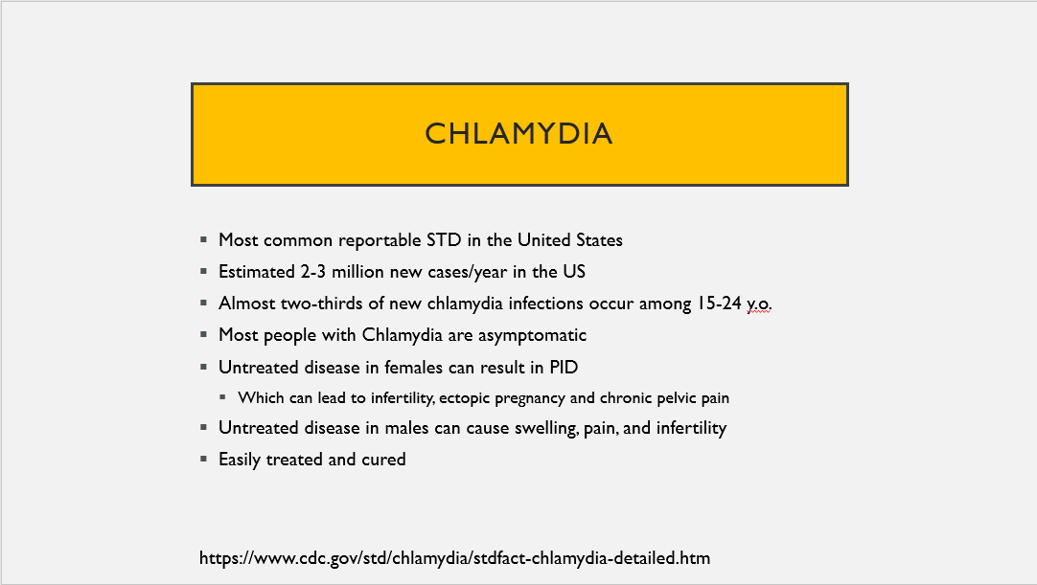

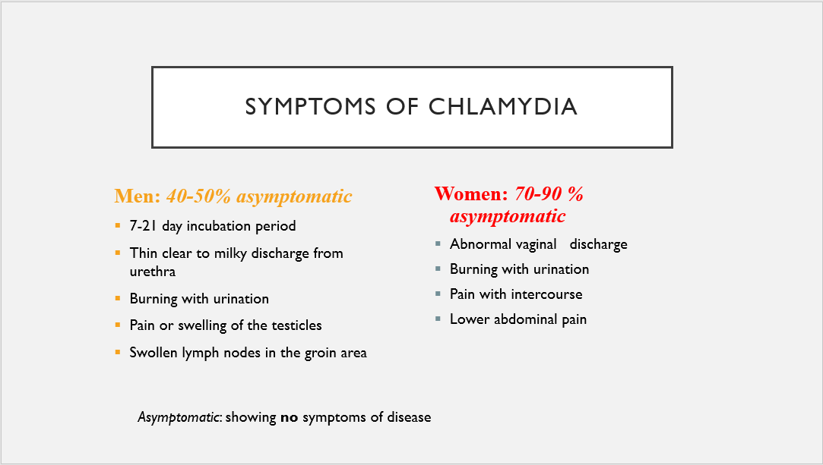

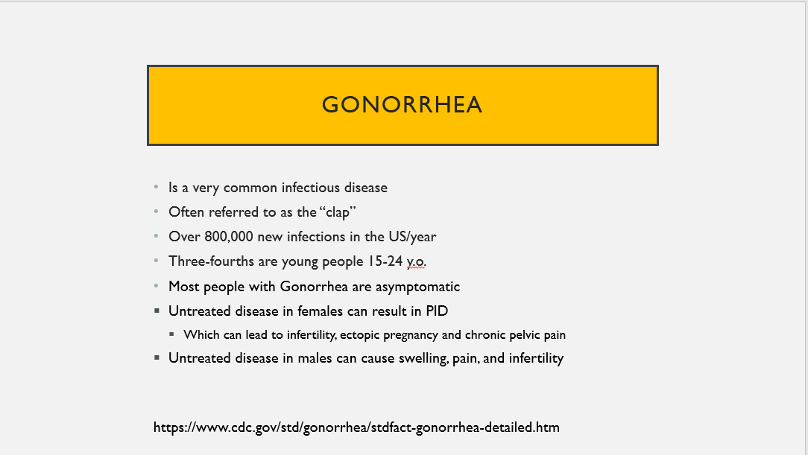

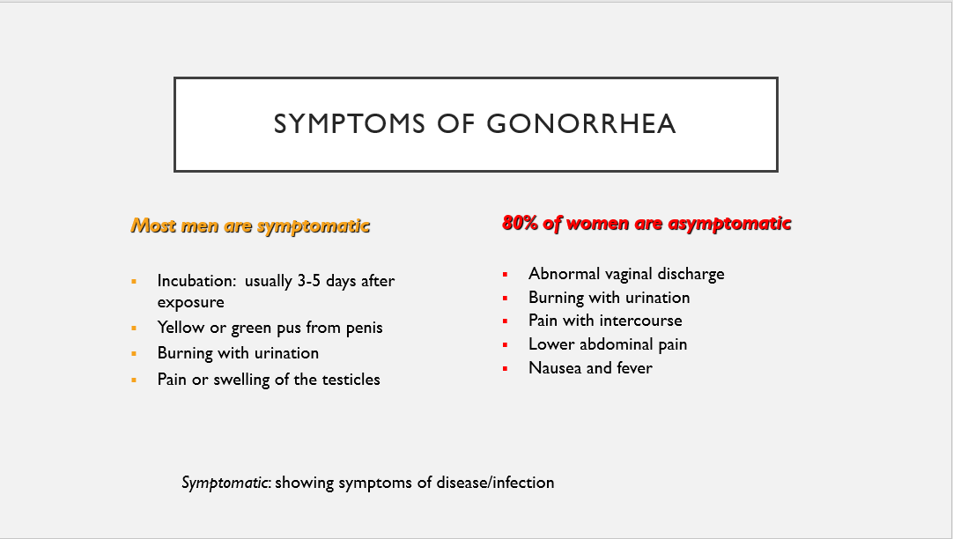

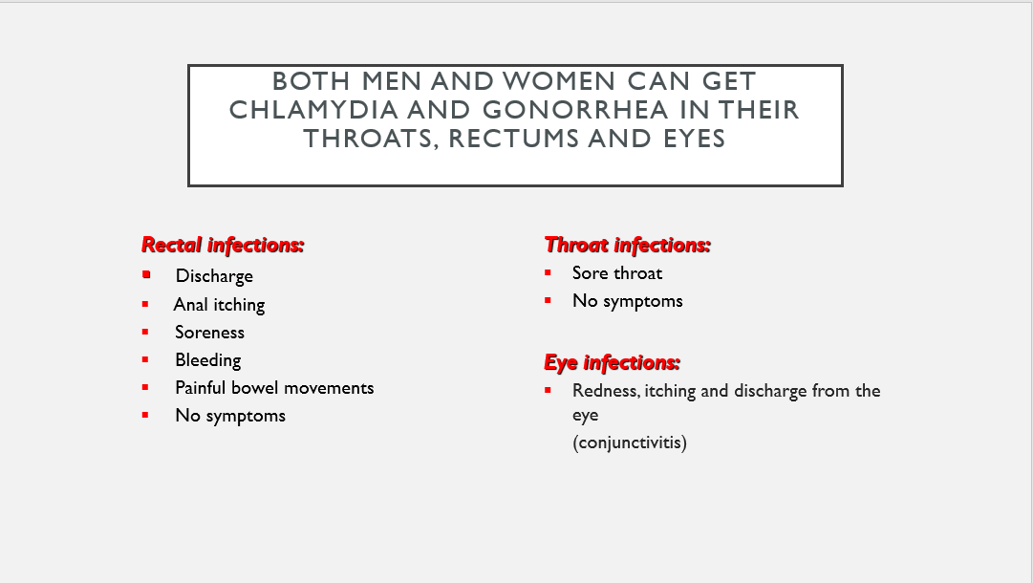

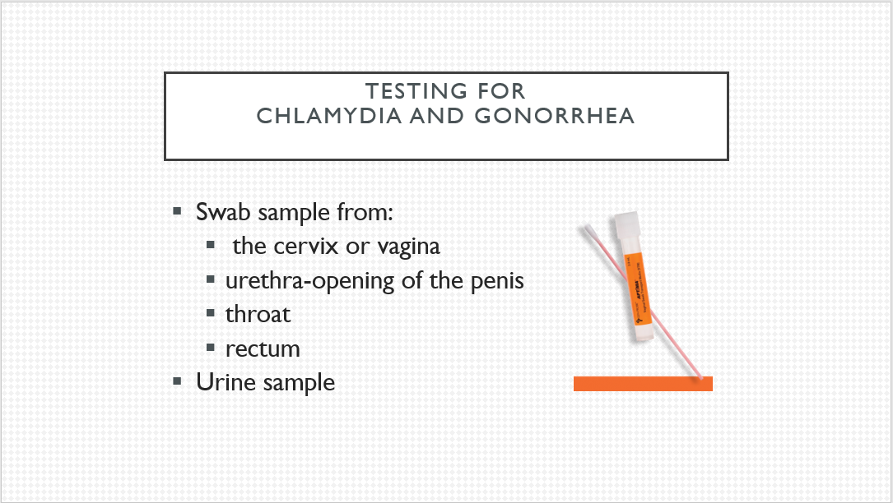

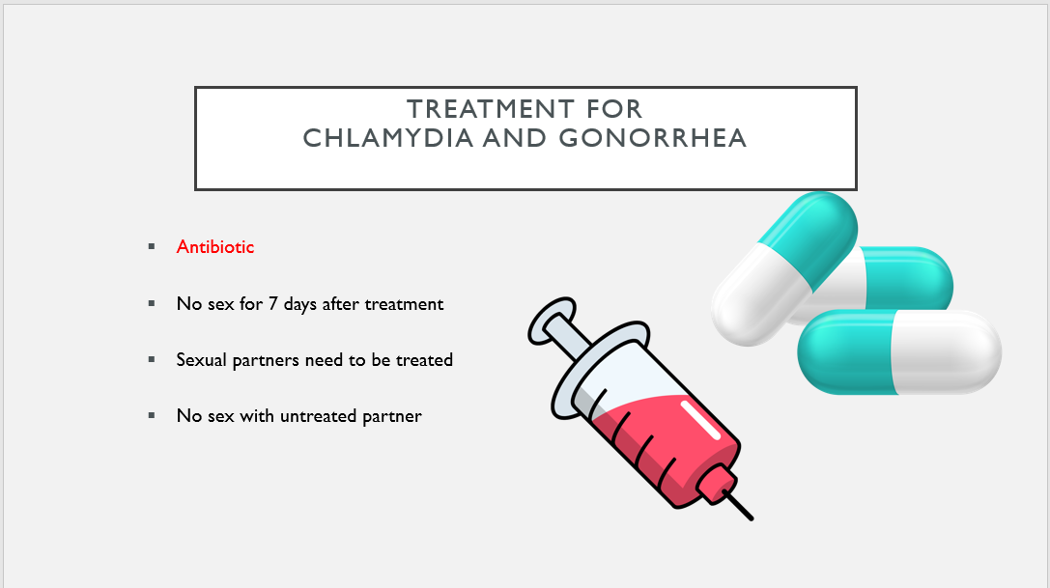

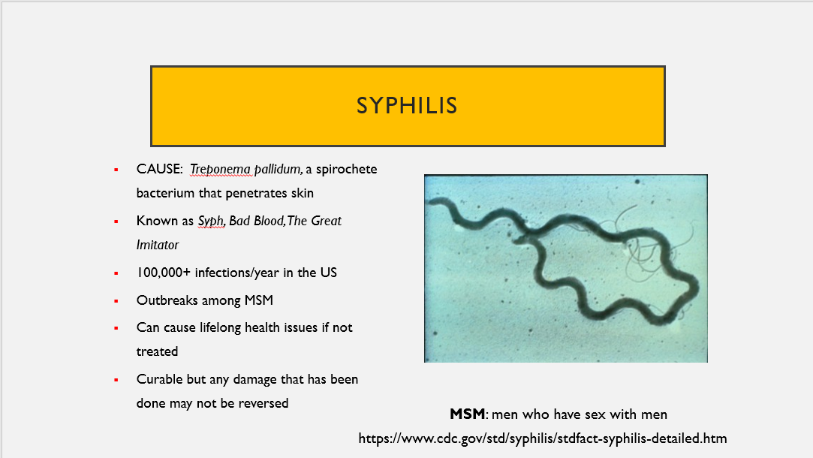

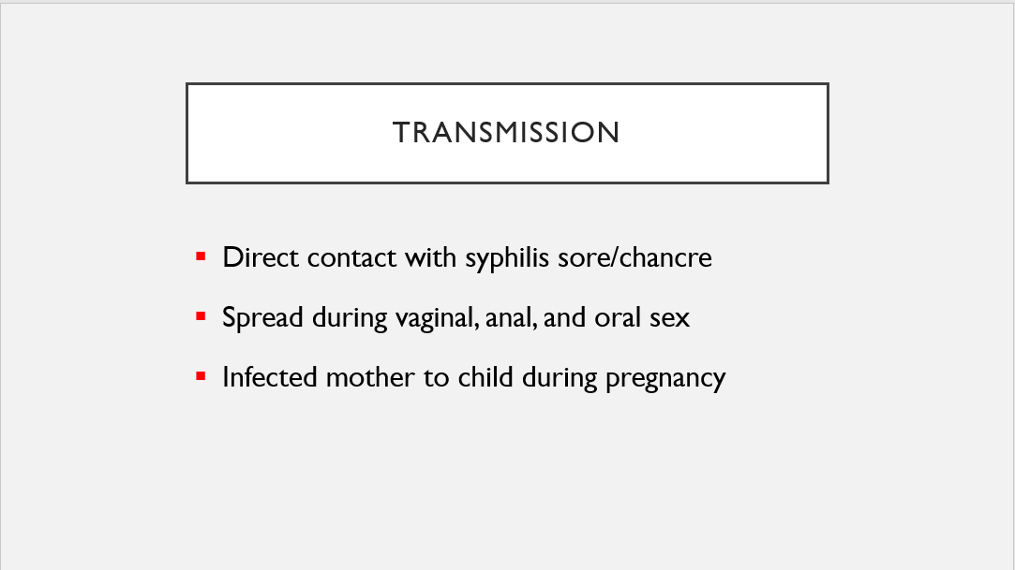

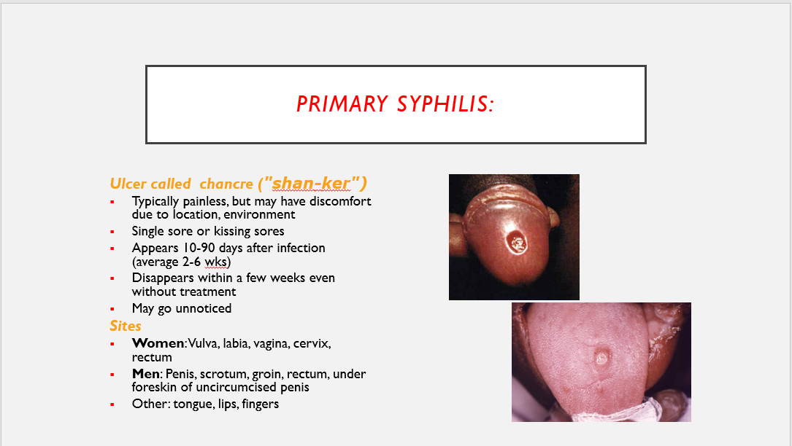

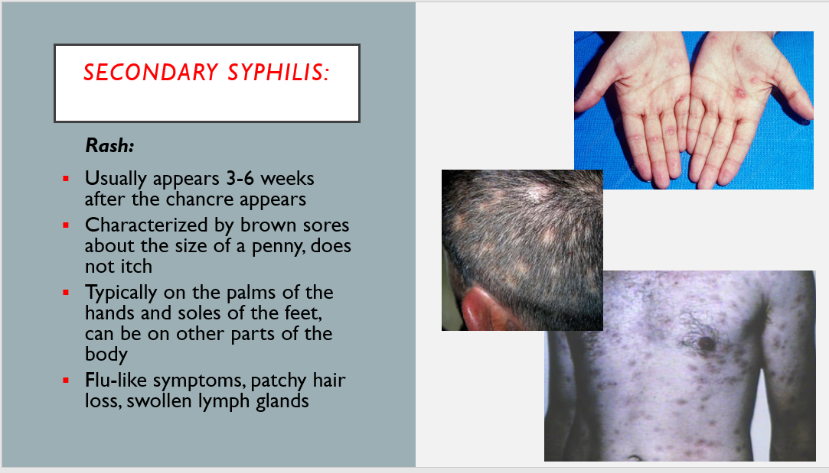

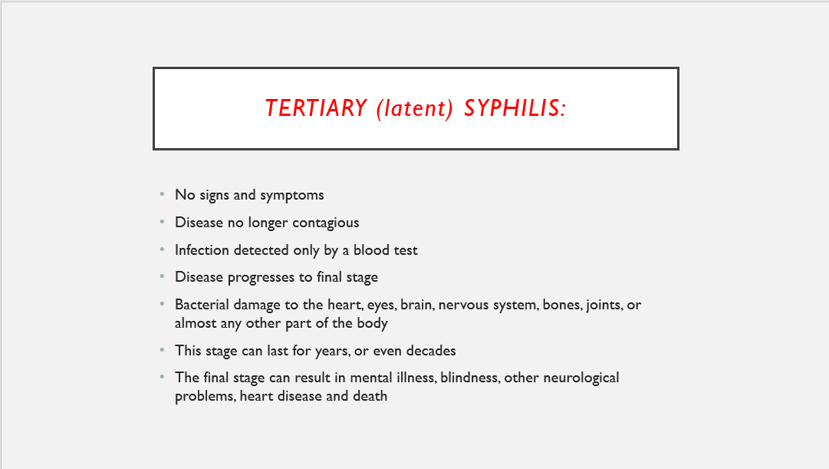

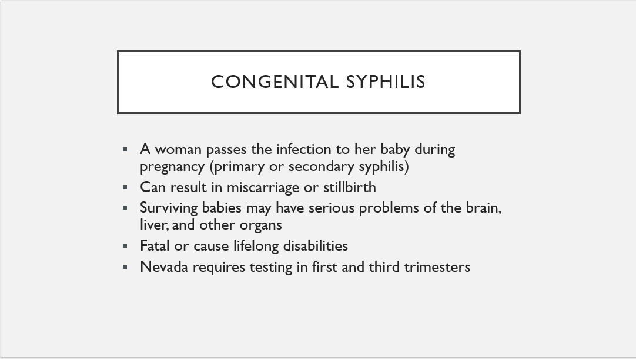

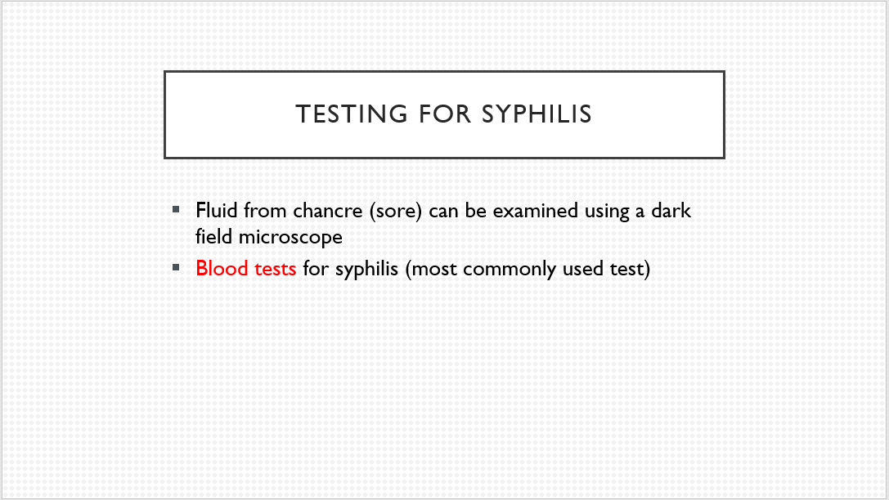

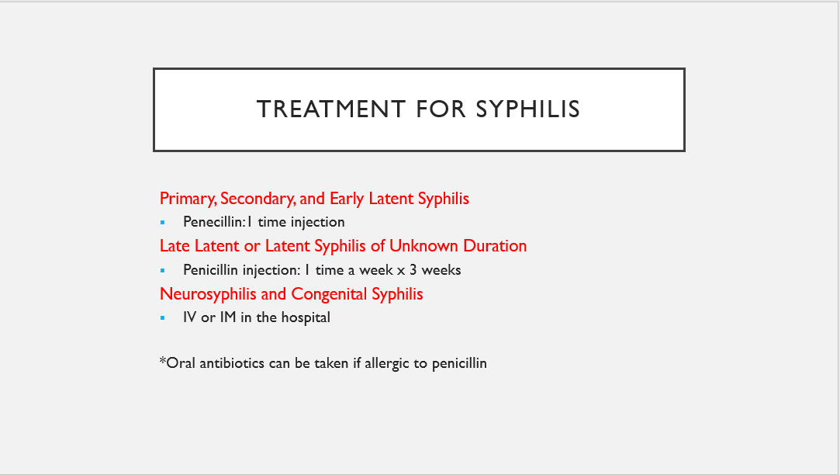



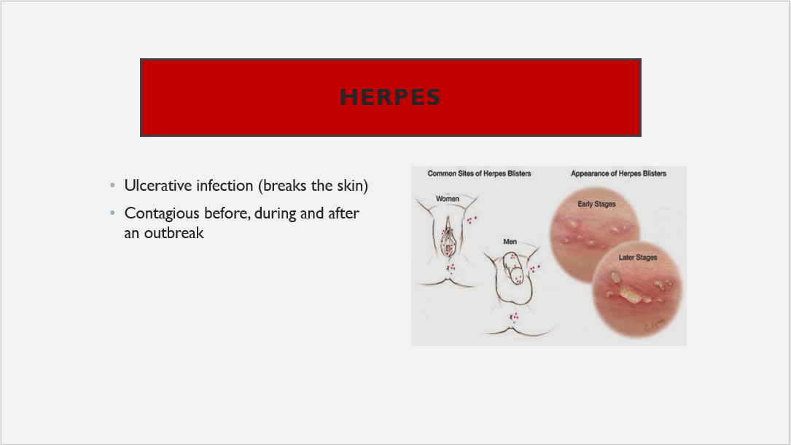

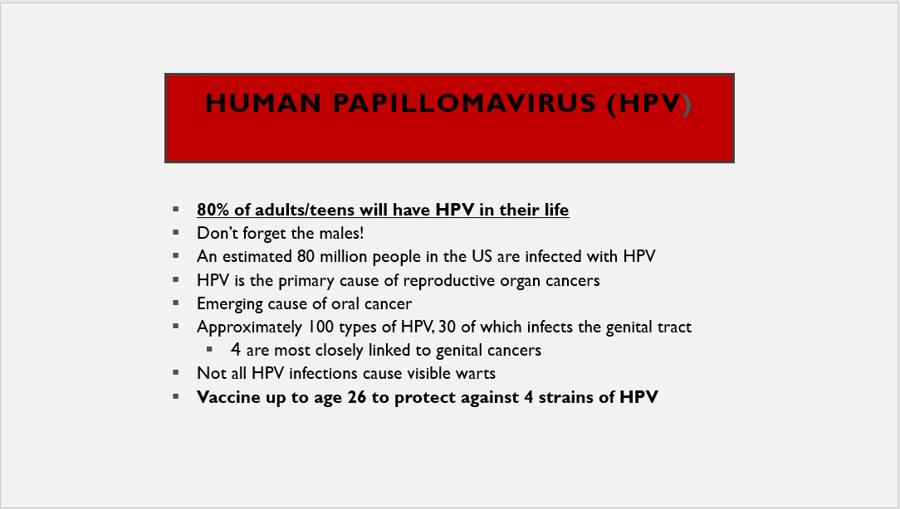

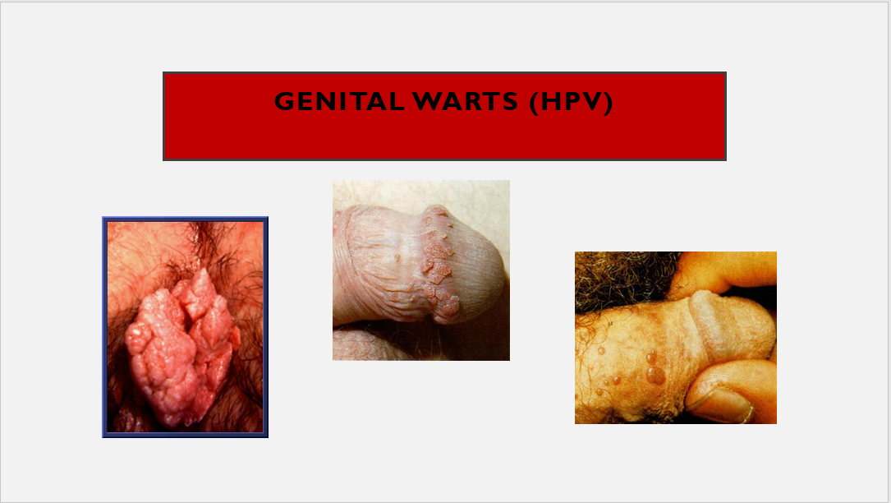

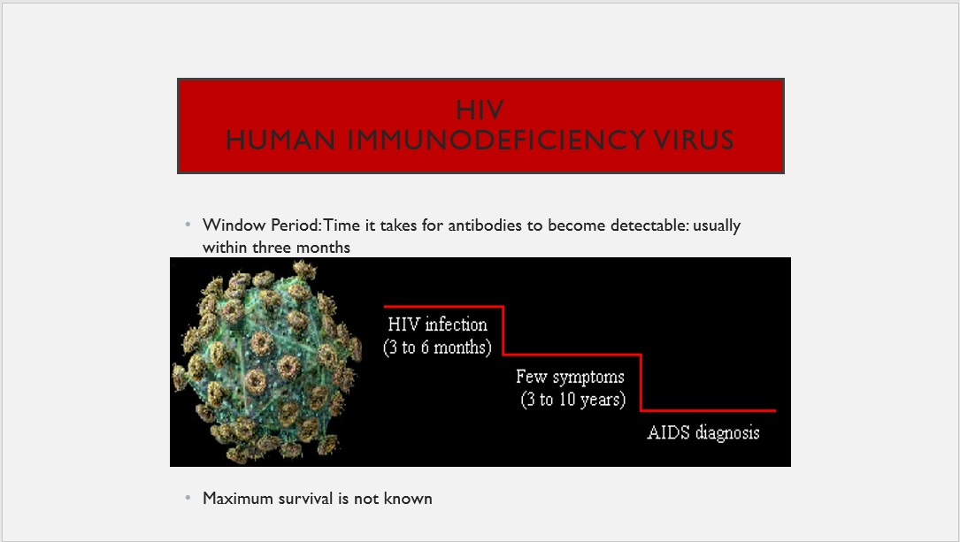

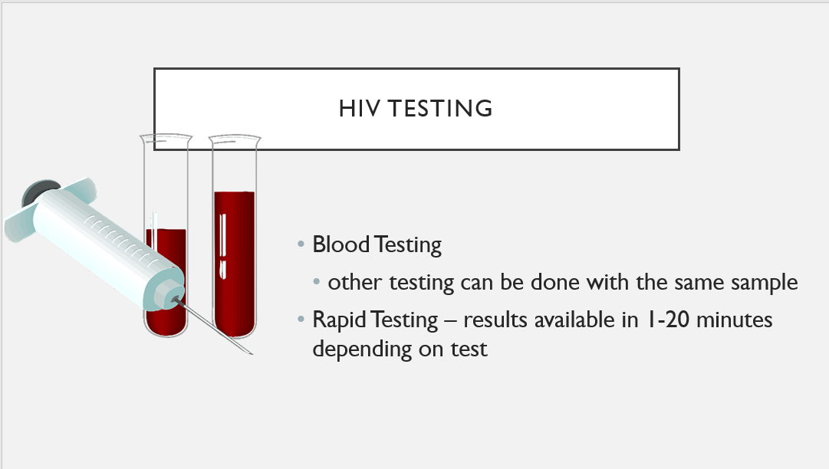

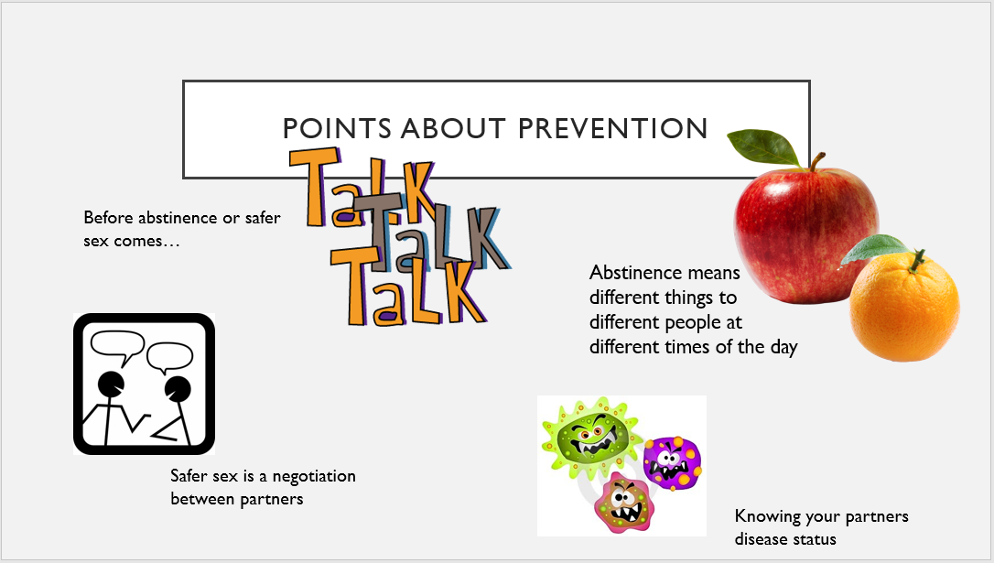



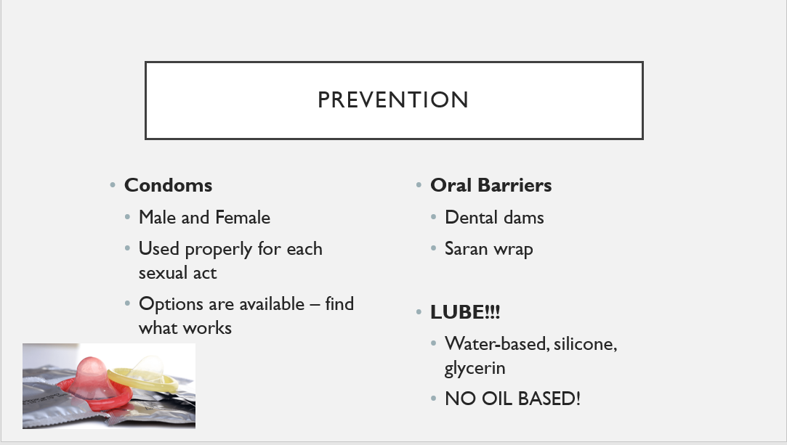

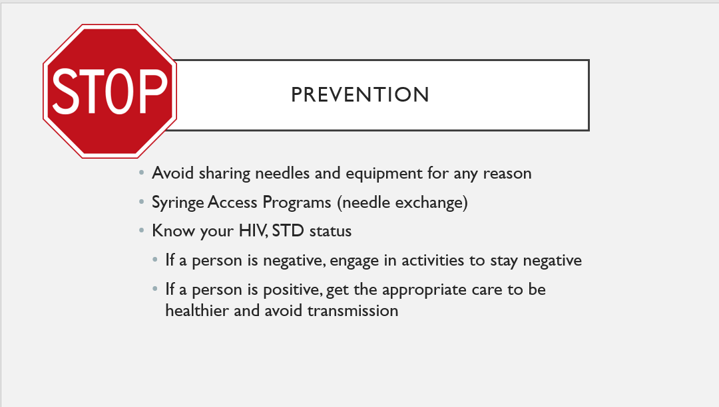

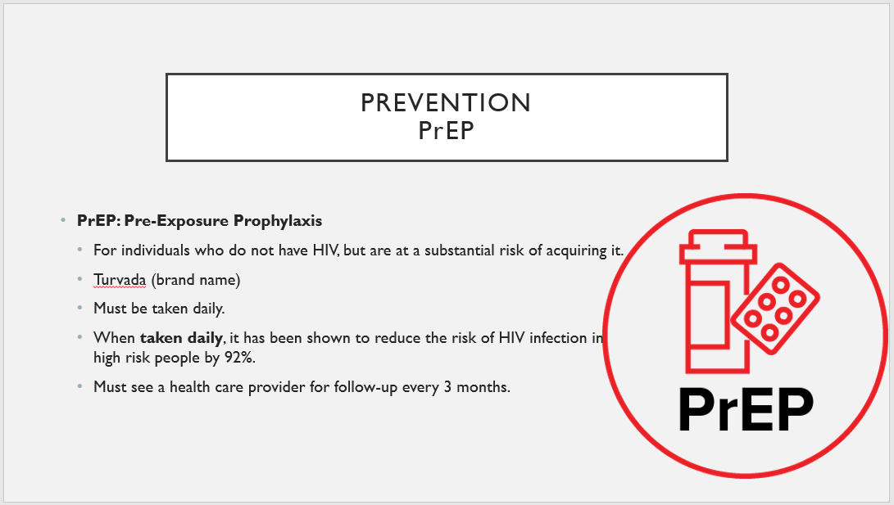

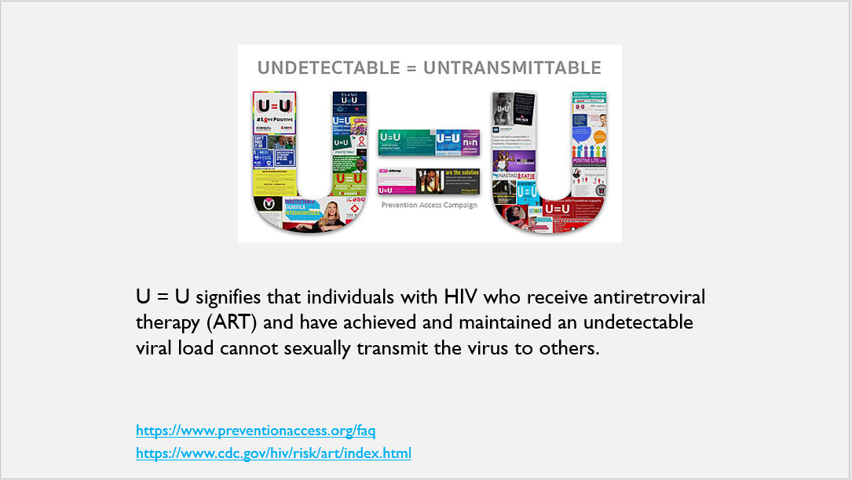

Slide 39- Let’s Talk About Sexual Health

Discuss possible options of who students can talk to in regards to their sexual health

Play video <https://vimeo.com/43631114>

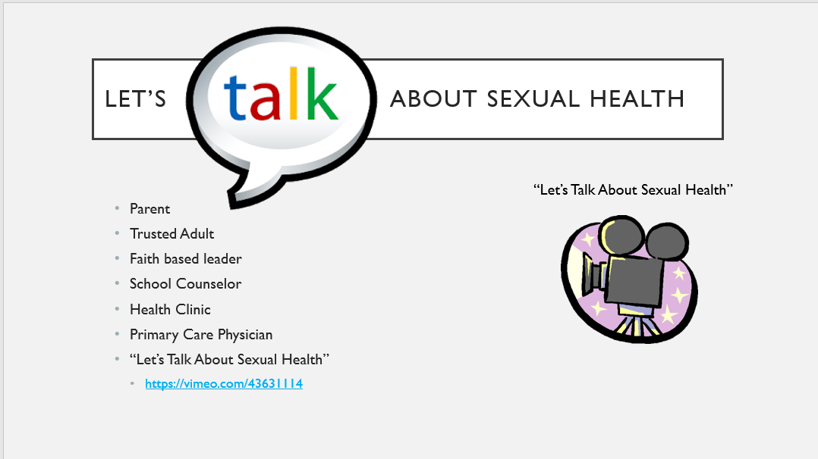

Slide 40- Where to go for testing

List student responses

Go to <https://gettested.cdc.gov/>

Walk students through how to use the resource

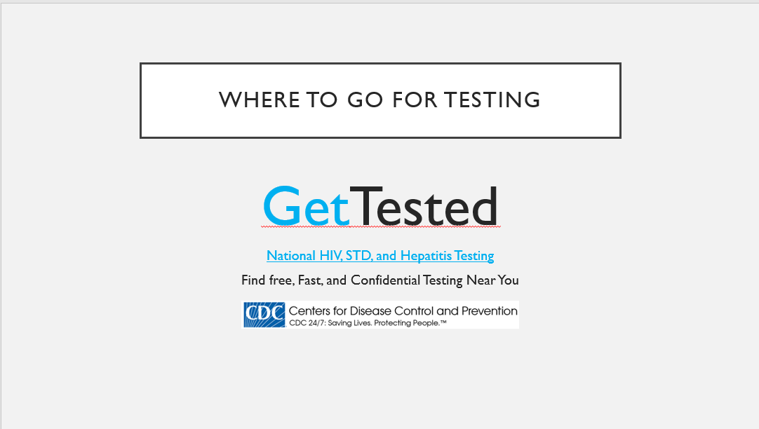

Time permitting

Jeopardy-STD Smarts PowerPoint